**

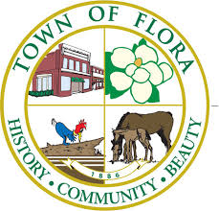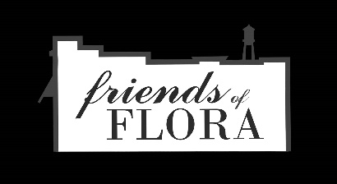

**HISTORIC FLORA DEPOT LANDSCAPE**

America In Bloom, Canadian National Railway, MS Urban Forest Council Event in Flora, MS

**When: April 20, 2021**

**Time:** 10:45 a.m. – 11:30 a.m.

**Where:** Historic Flora Railroad Depot

**Agenda**

10:45 AM Mayor Childress – Welcome, Flora History and Introductions

10:55 AM Donna Yowell – About the Landscape Project and Thanks to Grantors

11:05 AM Nathan Thomas – About Friends of Flora and Volunteer Thanks

11:15 AM America in Bloom – Laura Kunkle and Marvin Miller

Canadian National Railway

11:25 AM Sign Installation, Wrap up and Thank yous!